**MICROSOFT AZURE FUNDAMENTALS CLOUD COMPUTING**

**COURSE OVERVIEW**

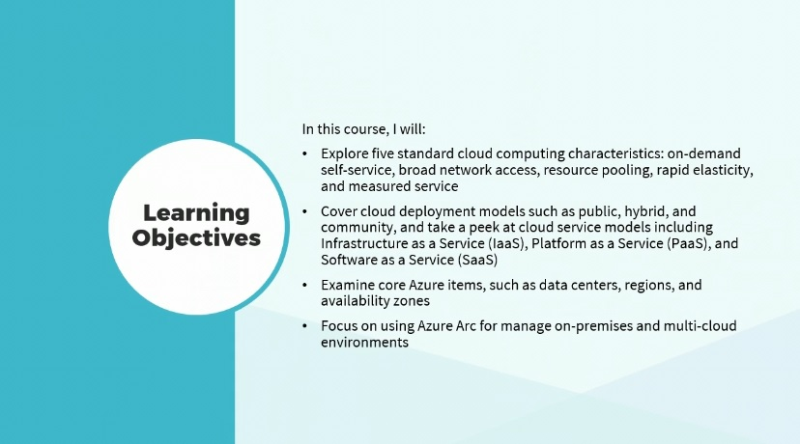

Hi there, I'm Dan Lachance.

The popularity of cloud computing has exploded in recent years.

Organizations can streamline IT service efficiency with the use of cloud services in the Microsoft Azure environment.

In this course, I’ll explore five standard cloud computing characteristics:

on-demand,

self-service,

broad network access,

resource pooling,

rapid elasticity, and measured service.

I will cover cloud deployment models such as public, hybrid, and community, and take a peek at cloud service models including Infrastructure as a Service or IaaS, Platform as a Service(PaaS), and Software as a Service (SaaS).

I will examine core Azure items, such as data centers, regions, and availability zones.

Finally, I will focus on using Azure Arc for managing on-premises and multi-cloud environments. This course can be used to prepare for exam AZ-900, Microsoft Azure Fundamentals.

**CLOUD COMPUTING CHARACTERISTICS**

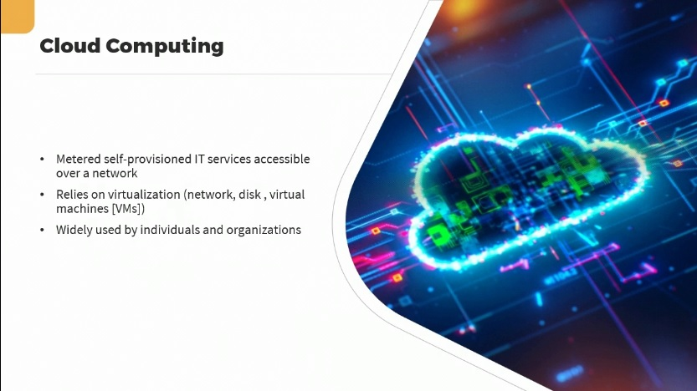

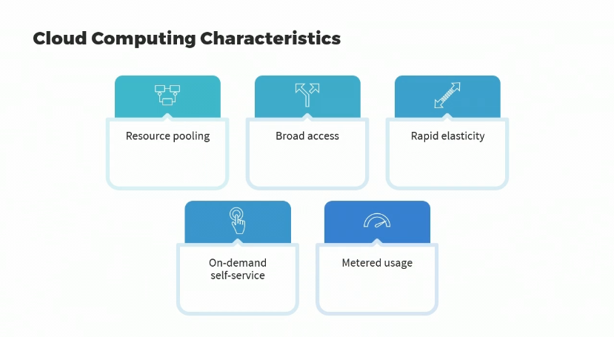

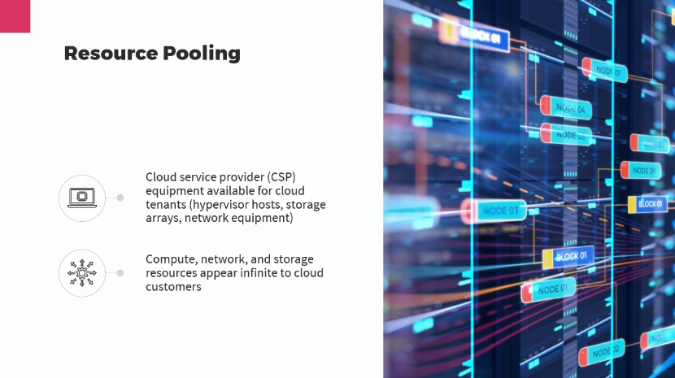

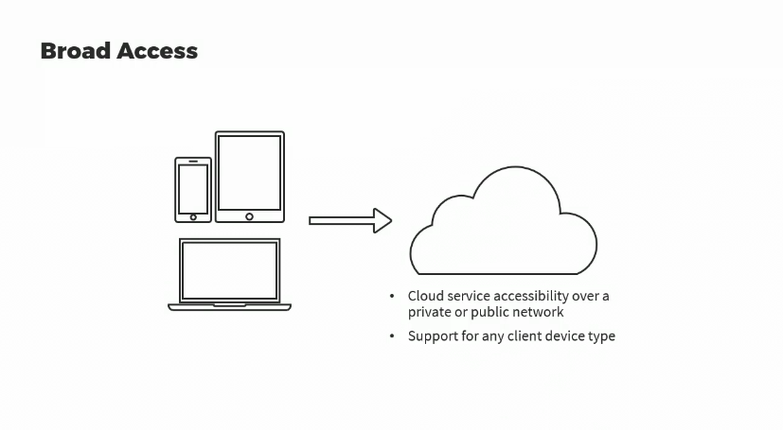

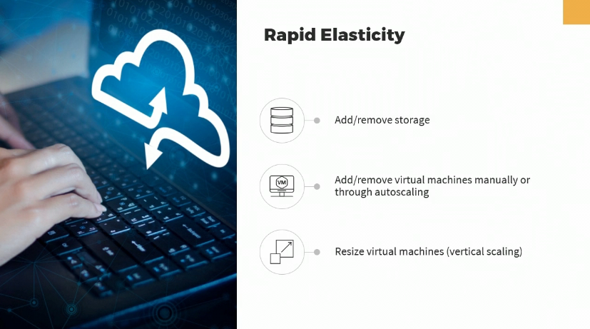

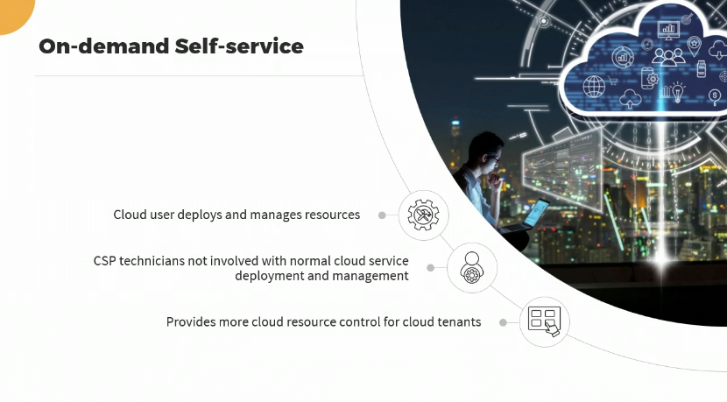

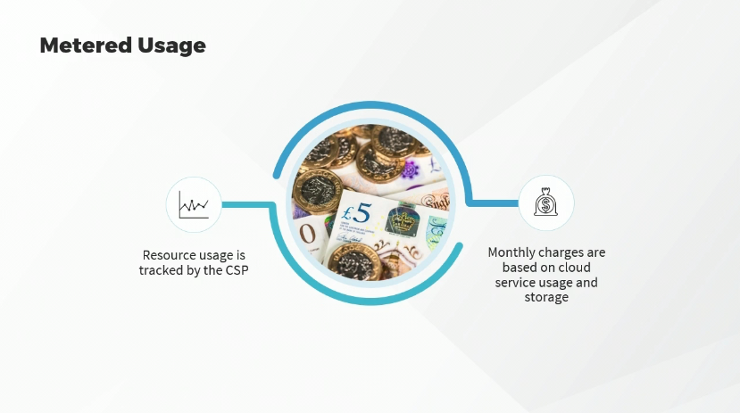

Understanding what makes cloud computing, **cloud computing, is one of the core concepts required for answering questions** on the AZ-900 exam.

Let’s focus on cloud computing.

Cloud computing essentially is a metered self-provisioned way to use IT services that are accessible over a network.

In other words, you’re connecting to IT services running somewhere else, on somebody else's equipment.

Cloud computing relies on virtualization in a number of different forms, such as, network virtualization, to allow us to configure virtual networks in the cloud, which can actually make changes to modify underlying network infrastructure equipment; disk virtualization, such as virtual disks used by virtual machines; and of course, running virtual machines or VMs on physical hypervisor hosts.

In this day and age, of course, cloud computing is widely popular for both individuals as well as organizations. But what makes using IT services cloud computing?

Let's define those characteristics.

The first characteristic is resource pooling.

Then we have broad access, rapid elasticity, on-demand self-service, and metered usage.

We're going to discuss each of these in a bit more detail.

Let's start with resource pooling.

What exactly does that mean when it comes to cloud computing? It means that the cloud service provider, otherwise known as the CSP, has buildings or rent space in a data center somewhere, where their equipment is available to be used by cloud customers or cloud tenants. So, having physical servers configured as hypervisor hosts, which can run multiple virtual machines; physical storage arrays that can be used for cloud storage; physical network equipment that can be used to allow networking of IT services available in the cloud. So, the resources are compute based, running virtual machines on hypervisors, network and storage, and these would appear to be almost infinite to cloud customers as the CSP can add underlying equipment as required to the cloud customer.

It just looks like they have more resources available.

They can deploy more space, let's say in a Microsoft Azure storage account, or deploy more virtual machines to be running concurrently.

And the economies of scale, where there are many cloud customers, make this affordable by CSPs in terms of purchasing the underlying physical hardware to allow the running of all of these types of IT services.

So, resource pooling is one cloud computing characteristic.

All characteristics have to be met in order to say that we have a cloud environment.

The next one is broad access. This means that the cloud services are available over a network, so you don't have to be running it on your own equipment.

Now, that can be over a private network, because you can have a private cloud and we’ll talk about that later or it might be available over a public network, such as customers accessing Microsoft Azure resources over the Internet.

Broad access also implies that we can connect from pretty much any type of device, whether it’s a smartphone, a server making API calls into the cloud, a desktop, a laptop, it doesn’t matter. So, broad access is our second cloud computing characteristic.

The third is rapid elasticity.

This means that we can do things very quickly with minimal configuration, because we're not dealing with the actual underlying hardware.

We're doing it through software virtualization, such as, the ability to easily and quickly add and remove storage, or the ability to easily and quickly add and remove virtual machines; whether we’re doing that manually or whether we’ve configured autoscaling, such as for a load balancer, when things get busy, it automatically adds virtual machines; when things quiet down, it removes them to save on costs.

Rapid elasticity also means that we can quickly resize a virtual machine.

This is called vertical scaling.

It means we can add more horsepower, more processors or faster processors, more RAM; we can do that in a matter of seconds, as opposed to in the real world, where you would have to order the appropriate equipment and configure it before you had that increase in underlying horsepower. So, that’s rapid elasticity.

The fourth cloud computing characteristic is called on-demand self-service.

This means that cloud customers, cloud users, are the ones that deploy and manage those cloud resources, such as virtual machines or storage accounts. Cloud customers don't send a helpdesk ticket to Microsoft asking for the creation of a virtual machine or a storage account.

The cloud customer does all of that.

So, therefore, cloud service provider technicians are not involved with standard cloud service deployment or management.

Of course, they might be involved when it comes to technical support, if cloud customers are experiencing problems. So, what this means is, it provides cloud resource control for cloud tenants.

They determine what gets deployed when, and in what way.

Our last cloud computing characteristic is metered usage.

This means that whatever we use in the cloud, resource usage, is tracked by the cloud service provider; much like electricity, the amount of electricity you use is tracked and you pay your bill accordingly. So, monthly charges for cloud computing then are based on cloud service usage and the amount of storage that you’re using.

One important aspect of the AZ-900 exam is having the ability to control costs in the Azure cloud, while maintaining service and availability. We’ll, be focusing on cost management later.

**VIRTUALIZATION AND THE MICROSOFT AZURE CLOUD**

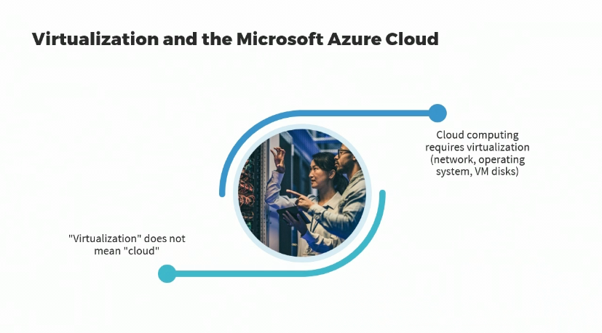

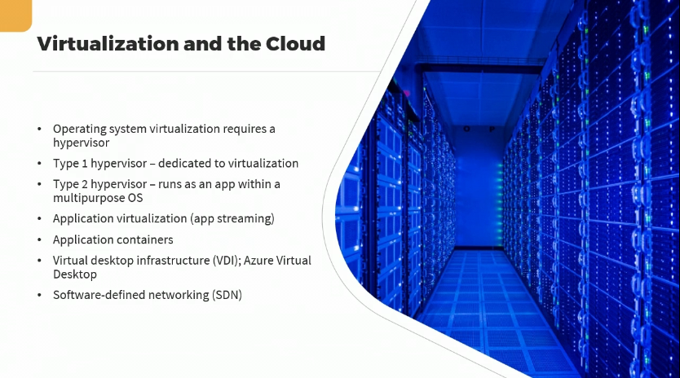

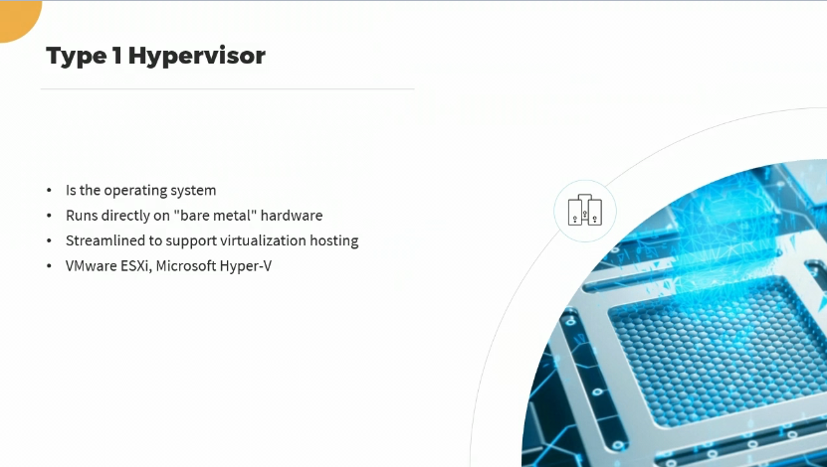

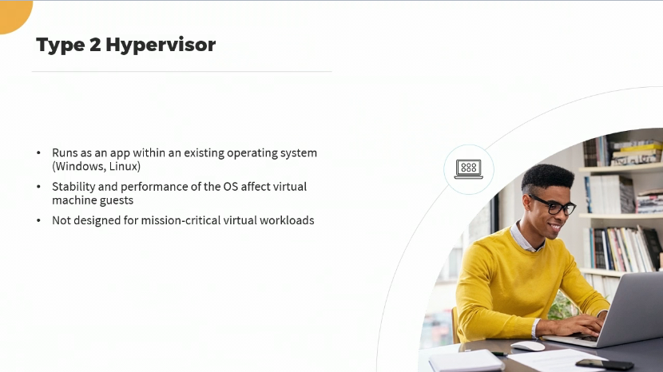

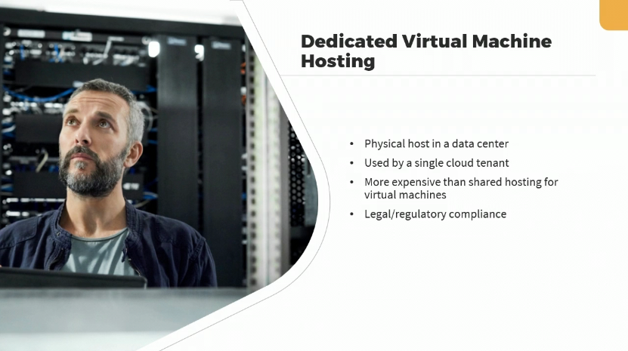

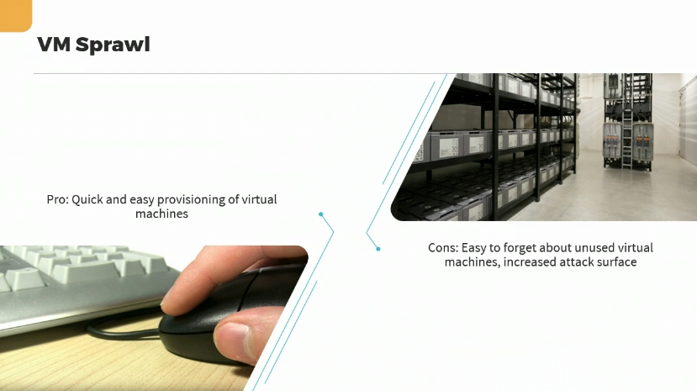

Virtualization is a very crucial part of cloud computing in the Microsoft Azure cloud.

However, virtualization unto itself doesn't mean that you have a cloud computing environment; although cloud computing does require virtualization in a number of forms at the network level, at the operating system level, for virtual machine disks.

So, let’s hone into some details related to virtualization and Microsoft Azure. When you deploy virtual machines in the Microsoft Azure cloud, whether that's done by you manually or whether it's done in the background because you’re provisioning some other type of service, either way, you are virtualizing an entire operating system, whether it’s a Windows client OS, a Windows Server OS, a Linux OS; you are virtualizing that OS.

It has to run on a hypervisor. And a hypervisor is a physical server with software that allows it to run multiple virtual machines and regulate access to the underlying hardware. Of course, all that happens in a data center somewhere else.

A Type 1 hypervisor, which is what you would find in a Microsoft datacenter for Azure, is dedicated to virtualization and nothing else. It runs virtual machines. That's what it does. The operating system that will do that will be a variant of the Windows Server OS, optimized for running Microsoft Hyper-V.

A Type-2 hypervisor for running virtual machines simply runs as an app within a multipurpose OS. If you’re running Type-2 hypervisor like Oracle VirtualBox or VMware Workstation that just runs as an app within the host OS.

We also have application virtualization, sometimes called app streaming.

We have application containers, which can run an entire app or one subcomponent of an app within a logical boundary, and that would be the container. So, all of the app files, everything it requires, is contained within the application container.

Another form of virtualization would be virtual desktop infrastructure or VDI. In the Azure cloud we call that Azure Virtual Desktop, AVD. It allows clients wherever they happen to be, and regardless of which type of device they are actually using, it allows them to connect to a Windows desktop that’s actually running and being hosted in the Azure cloud, which could also include applications. So, it doesn’t need to all be installed on the local client device.

Virtualization in the cloud also comes in the form of software-defined networking or SDN, which would allow cloud customers to do things like configure firewall settings, configure virtual networks, all without having to have the knowledge to modify the underlying physical network infrastructure equipment.

They can do it with just a few clicks or by just typing in a few commands. So, we know then, that a Type 1 hypervisor is what’s used in the Microsoft Azure cloud to run virtual machines.

The hypervisor is the operating system, and it runs directly on real hardware, otherwise called “bare metal”.

Type 1 hypervisor operating systems are optimized or streamlined to support virtualization hosting.

We've mentioned that Microsoft Hyper-V falls under this category, as well as VMware ESXi to name, but just a few.

We know that a Type 2 hypervisor just runs as an app within an OS, whether it’s a Windows or a Linux-based OS.

However, the stability and performance of that OS will directly affect virtual machine guests. So if the OS isn’t stable, neither will the virtual machines be. So, this is not designed for mission-critical virtual workloads.

Well then, what is it good for? It’s good for testing, it’s good for developers, it’s good for training purposes, that type of thing.

In Microsoft Azure, you can also enable dedicated virtual machine hosting. This means that you have a dedicated hypervisor host, a physical host in a data center that will only be used by a single cloud tenant.

You can have only your virtual machines running on that host, not other as your customers. As you might imagine, that would be more expensive than shared hosting for virtual machines, which is the norm in the Microsoft Azure cloud, but it is an option that we should at least be aware of.

You might lean more towards this dedicated virtual machine hosting for legal or regulatory compliance, where privacy is a paramount concern. But one thing to watch out for in the cloud is VM sprawl.

We know that there is a benefit to how quick and easy it is to provision virtual machines in Microsoft Azure. That’s one of the benefits of using cloud computing, self-service management, rapid elasticity. And that's great. It allows you to get virtual machines spun up and running very, very quickly. However, the downfall to this is that it can be easy to forget about virtual machines that have been deployed in the past, but are no longer in use. So, by forgetting about virtual machines that are deployed, perhaps running, that can increase the attack surface.

Even if they're not running, they're still using storage somewhere. So, not only will that incur cost, but it still serves to increase the attack surface, in case things like virtual disks get compromised where they might contain sensitive data.

Luckily, we have tools that will allow us to identify idle or unused cloud services so we don't have to go looking for it manually.

And in this way, we can be very efficient about our cost management and also about reducing the attack surface.

**CLOUD DEPLOYMENT MODELS**

